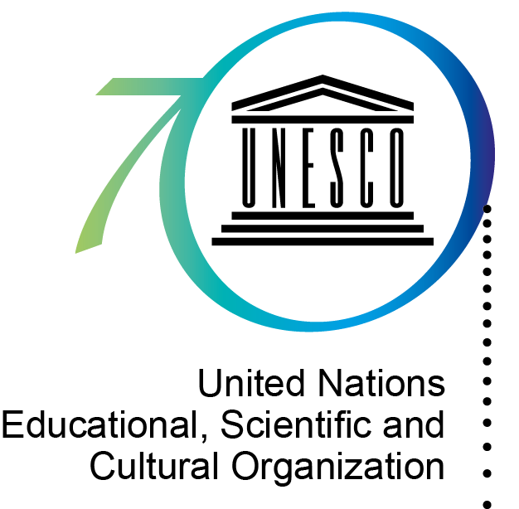


UNESCO-Japan Prize on
Education for Sustainable Development (ESD)
2015 Nomination Form

Background

Within the framework of the Global Action Programme (GAP) on ESD, the UNESCO-Japan Prize on Education for Sustainable Development (ESD) honours individuals, institutions, organizations or other entities engaged in ESD activities. The Prize was established by the Executive Board of UNESCO at its 195th session, and officially announced at the UNESCO World Conference on ESD (10-12 November 2014, Aichi-Nagoya, Japan). The Prize consists of three annual awards of US$ 50,000 for each recipient.

Nominations

Nominations can be made by governments of Member States and non-governmental organizations in official partnership with UNESCO. Nominations must focus on a specific ESD project or programme of the nominee. Each government or non-governmental organization can make up to three nominations.

Selection Criteria

The three Prize winners will be selected by the Director-General of UNESCO on the basis of recommendations made by an international independent jury consisting of five experts. The project/programme of the nominee will be assessed by the Jury on the basis of the following criteria:

a. Transformation: The project/programme practices ESD as transformative education in support of sustainable development.
ESD is transformative education in that it empowers learners to transform themselves and the society they live in. The nominated project/programme should therefore enable learners to bring about changes for a more just, peaceful and sustainable world. This can mean, for example, taking action against climate change, changing one’s consumption patterns, developing social entrepreneurship and sustainable livelihoods, or supporting those struggling against poverty.

b. Integration: The project/programme addresses the three dimensions of sustainable development (society, economy, environment) in an integrated way.
Sustainable development calls for the integration of the social, economic and environmental dimensions of development. The nominated project/programme should be in line with this definition of sustainable development. It should address the three dimensions (society, economy, environment), and help learners understand the interdependence between them and act accordingly.

c. Innovation: The project/programme demonstrates an innovative approach to ESD.
Sustainable development requires going beyond ‘business as usual’ and ‘out-of-the-box’ thinking. The nominated project/programme should demonstrate an innovative approach to ESD, be it in the themes it covers, the methodology it employs, or the way the learning environment is designed. Reaching out to sectors beyond education and working with new partners can also be a sign of innovation.

In addition to these three criteria, the project/programme should have a high impact relative to the invested resources, should be replicable and scalable, and should contribute to one or more of the five Priority Action Areas of the GAP.
Submission Procedure

1) Kindly complete the ESD Prize Nomination Form in English or French.
You can attach relevant supporting materials (e.g. publications) to the Form. Supporting materials should be less than twenty pages in total.

2) The Nomination Form must be accompanied by a written recommendation in support of the nominee by the nominating party. Self-nomination cannot be considered.

3) Submit the Nomination Form and any supporting materials to UNESCO via email to esd@unesco.org. The documents must be received by UNESCO by 31 May 2015. Nominations can only be accepted from the official email accounts of Permanent Delegations to UNESCO or non-governmental organizations in official partnership with UNESCO.

4) Supporting documents, if not attached to the nomination email, should be duplicated five times and sent by post to the following address:

Section of Education for Sustainable Development
Division for Teaching, Learning and Content
Education Sector
UNESCO
7 Place de Fontenoy 75352 Paris 07 SP
France

1. Nomination submitted by (please tick one)
Member State
[type in the name of the Member State]

Non-governmental organization (NGO) in official partnership with UNESCO
[type in the name of the NGO]

2. Information on the nominated organization/individual
Name
Type of organization/ individual | Please tick one:  Government  International Organization  Civil society organization  Business  Media  Academia/research institution  Education institution  Individual  Other [Please specify]
Postal Address
Country
Contact person | [Name, Title, Department]
Email address
Telephone
Website
Description of the nominated organization/ individual | [Please provide a summary description in about 150 words.]

3. Description of the project/programme of the nominee
a. Name of the project/programme
b. Abstract
[Please explain the objective of the project/programme and its methodology in about 150 words.]
c. Contribution to the GAP
Please tick the Priority Action Area of the GAP to which the project/programme mainly contributes (please tick only one):
Advancing policy
Transforming learning and training environments (whole-institution approaches)
Building capacities of educators and trainers
Empowering and mobilizing youth
Accelerating sustainable solutions at local level
d. Main target group(s)
Please tick one (or more) and specify:
Governments (National/ Sub-national/ Local) [Please specify]
Intergovernmental organizations [Please specify]
Civil society organizations [Please specify]
Business [Please specify]
Media [Please specify]
Academia/research institutions [Please specify]
Education institutions [Please specify]
Educators [Please specify]
Youth [Please specify]
Other [Please specify]
e. Geographical coverage
Please tick one:
International [Please indicate the number of countries]
Regional [Please indicate the regional area]
National [Please indicate the name of the country ]
Local [Please indicate the name of the local community ]
f. Number of beneficiaries
[Please indicate the number of beneficiaries]
g. Duration
The project/programme started in: [month/year]
The project/programme has a duration of: [years(months)]
h. Funding
[Please explain the funding source(s) of the project/programme.]
i. Resources
Annual cost of the project/programme:[USD]
Number of staff involved in the project/programme per year:
j. Follow-up plan
[Please describe the follow-up plan of the project/programme, indicating information such as scaling-up strategy, target groups, duration and budget, in about 150 words.]
k. Impact
[Please explain the impact that the project has had, using concrete information such as feedback from participants, number of site visits to the project website or citations, in about 150 words.]

4. Information on the project/programme with regard to the selection criteria
a. Transformation:
[Please describe how the project/programme exemplifies ESD as transformative education in support of sustainable development in about 200 words.]

b. Integration:
[Please describe how the project/programme addresses the three dimensions of sustainable development (society, economy, environment) in an integrated way in about 200 words.]

c. Innovation:
[Please specify how the project/programme demonstrates an innovative approach to ESD in about 200 words.]

List of attached supporting materials (e.g. publications)
1.
2.
3.
4.
5.
…

